The Order of Worship
June 3, 2018
10:00am

WE GATHER TOGETHER IN JESUS’ NAME

Opportunities for Growth

*Call to Worship Psalm 139:1-3
¹ You have searched me, Lord,
and you know me.
² You know when I sit and when I rise;
you perceive my thoughts from afar.
³ You discern my going out and my lying down;
you are familiar with all my ways.
*Praise Music
10:00am “Build My Life”
“ Father God” #141
*Call To Confession
O Lord God Almighty, Ruler of heaven and earth; we dare not lift our eyes into the brilliance of Your holiness. Cover us, we pray, with the cloak of Your mercy and the grace of Jesus Your Son. Then may we wholeheartedly turn from all that would keep us from Your holy love and fly into Your waiting arms for refuge and strength. Amen.
*Silent Prayer
*Assurance of Pardon
Pastor: Friends, hear and believe the good news of the gospel:
People: In Jesus Christ, we are forgiven!
*Our Response “Let There Be Glory” #20
*Passing Of The Peace
Pastor: The Peace of the Lord Jesus Christ be with you.
People: And also with you.
*Song of Preparation “Lord, Be Glorified” (vs 1) #186

*Prayer of Illumination
Let the words of my mouth
And the meditations of my heart
Be acceptable in your sight,
O Lord, my strength and my redeemer. AMEN

PRESENTATION OF THE WORD OF GOD
Children’s Sermon
*Scripture Isaiah 63: 15-16 (NIV)
L: The Word of God for the People of God.
P: Lord, we are listening.
Sermon “God, the Father” Pastor Ron Schermerhorn

WE SERVE THROUGH GIVING
Call to Offering
Offertory
*Doxology
*Prayer of Dedication for the Offering
The Sacrament of the Lord’s Supper
(Please take the bread and the cup as they are shared, so that all may partake together.)
The Lord’s Prayer
*Hymn “Holy, Holy, Holy! Lord God Almighty” #3

WE PART TO SERVE THE LORD
The Charge and Benediction
*Postlude “Open Our Eyes, Lord” #633
*All Who Are Able May Stand
Welcome!
We joyfully welcome all who have come to celebrate God’s best gift to all of humanity, Jesus the Christ, our Lord and Savior. Let every hand be extended in fellowship and good will as we greet and share with one another. “We love because He first loved us.” (1 John 4:19)

Shut -Ins
Carol Namendorf Nancy Miller Cassie Weichey
Luther Shoop Lois Stephenson John and Joann Cranmer
Prayer List
If you would like our congregation to be praying for someone,
please call or email the church office.
Lynn Morrow
Phoenix Betty Herold Bert Lawton
Gus Angerett Jarrett Hoover Karl Evans
Meghan Best USA/Military Johnny Eckert

Today’s Worship Flowers are provided by Carol & Hap Burns
In Honor of their 12th Wedding Anniversary
In Honor of George & Ruby Olenic’s 12th Wedding Anniversary
AND
In Honor of Pastor Ron & Heather for their one year Anniversary
of joining us here at Mount Chestnut Presbyterian Church

Help is needed!
If you are available on Wednesday June 13, 2018 at 6:00pm,
could you please lend a helping hand at the Mission House as the Deacons unload food purchased for their “Summer Lunch Program”?
Please sign up on the bulletin board if you are able to help…

Mount Chestnut Presbyterian Church
“…helping people to live in God’s love”
727 West Old Route 422, Butler, PA 16001
Phone: (724) 287-7601 Fax: (724) 287-0715
Email: mtchestnutchurch@zoominternet.net
Website: mtchestnutchurch.com or mcpresby.com
You can email Pastor Ron at: pastorron@zoominternet.net

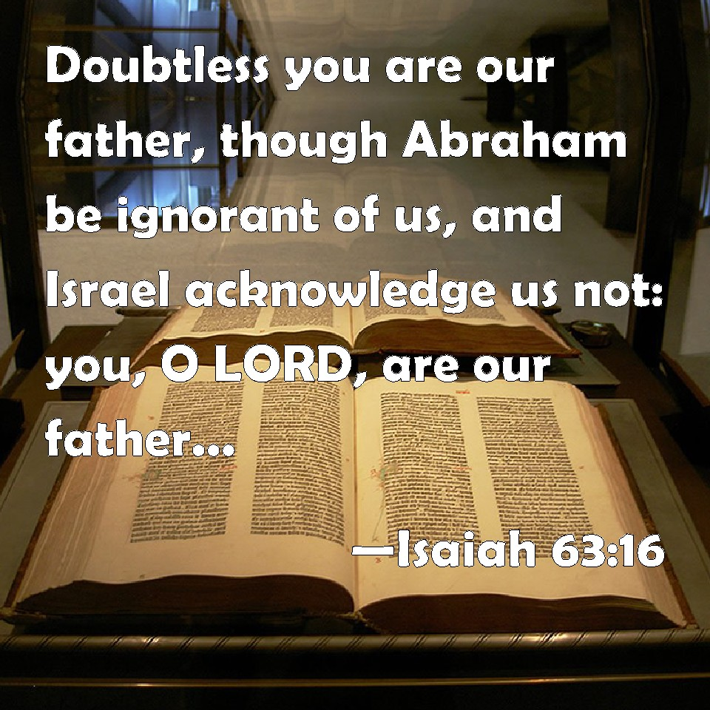

The Mount Chestnut Presbyterian Church
Worship June 3, 2018
10:00am

June 3, 2018
Today -10:00am Worship with Communion
-1pm ACTS Rehearsal

Monday -10:00am Seniors
-5:00pm Deacons Picnic
-6:30pm Food Cupboard
-8:00pm AA/-Alanon

Tuesday -6:00pm Active Shooter Training
-7:00pm H4BH Meeting

Wednesday -6:00pm Team Meeting

Thursday -10:00am Seniors
-8:00pm Bible Study with Michael Dean
Friday -
Saturday -

Next Sunday June 10th, 2018
-10:00 am Worship with Dave Fox
-1:00-8:00pm Picnic Shelter Rental

Announcing the 2nd quarterly TEAM Meeting for all committee members & leaders, Elders, Deacons and Staff. This will be on Wednesday,
June 6th at 6:00pm
Our last meeting was very helpful and informative,
we hope to continue these efforts for planning and organization.

Active Shooter Training
Please join us on June 5th at 6pm as Sgt Harry Callither of the Butler County Sheriff’s Department shows us what to do in an active shooter situation.
No one is out of harm’s way and this training could make a difference.
Hope to see everyone there…

Mt. Chestnut Presbyterian Church ~~ Staff
Pastor Rev. Ron Schermerhorn
Music Director Michael Dean
Organ & Piano Carla Osborne, Gary Kelly
Youth Directors Rachel Laughlin, Sarah Laughlin
Secretaries/Office Carisa Barnett, Anita Rodgers
Financial Secretary Marianne Hastings
Preschool Teachers Michele Gonda, Tricia Dulya
Preschool Directors Jodi Cygan, Debra Evans, Amanda Montag-Farina
Custodian Joyce Laughlin
AV Technician Amy Metrick

This Week (June 3, 2018)
Lay Leaders 10:00am – Sierra Nagy
Audio/Visual 10:00am – Amy Metrick
Greeters 10:00am – Don & Janet Boardman
Ushers 10:00am – Allison Montag, Matt Liwski, Mike Farina and
Amanda Montag-Farina
Communion Elders 10:00am – Donna Lee Hibbs, Chuck Morrow, Rob Borland, Cathy Metrick, Amanda Montag-Farina, Joel Reiger
Children’s Church

Next Week (June 10, 2018)
Lay Leaders 10:00am – Jodi Boory
Audio/Visual 10:00am – Melissa McCandless
Greeters 10:00am – Bud & Connie Sarver
Ushers 10:00am – Dan & Carla Metrick, Bud & Connie Sarver
Children’s Church

May 27, 2018 Worship
Offering $2,799.00 Attendance 106

Vacation Bible School
Come join us on our Christmas Journey!!!
Sunday June 24 thru Thursday June 28 from 6pm – 8:15pm
(Watch the bulletin board for signup sheets and donations!)

Small Group Bible Study - Summer
We have a new bible study led by Michael Dean beginning June 7 at 8:00pm for 6 weeks. The emphasis will be “The Essentials of Effective Prayer” This is open to anyone wishing to attend. It will be held here at the church. Contact Michael if you have any questions.

June Ladies Lunch Bunch
"Ladies Lunch Bunch invites all women to join us on an outing to Phipps Conservatory and Botanical Gardens on Tuesday, June 12, 2018. Descriptive information and sign up sheet is on the bulletin board. We will be car pooling and will be glad to take anyone that does not want to drive. Lunch will follow at a restaurant in Cranberry.
Contact Mary Moser if you have any questions at 724-712-6421 or email: gmbufl@gmail.com."
Substitute Custodian Position
Mt. Chestnut Church now has a great service opportunity for someone who enjoys cleaning and may like to earn a little extra income. A Substitute Custodian is needed to cover basic church cleaning duties when the regular custodian is unable. This position does not have a regular schedule, but will be utilized as needed. Upcoming pre-scheduled needs include July 14 – July 21 and Oct 11 – Oct 29. Limited days may be added as circumstances require. Please direct questions or indicate interest to Susie Beardsley (724-496-0257) or Pastor Ron.
Mount Chestnut Christian Preschool
We are now accepting registrations for 3-5 year olds for the 2018/2019 school term. Spread the word, it’s a great place for children to learn in a loving and Christian atmosphere.
2 and 3-day classes available.
Church Camp Scholarship
Summer is almost here!!! If any of your children are interested in attending a church camp this summer, please fill out a Christian Camp Fund Application which is located in the racks by the Bulletin Board. For 2018, Mount Chestnut Presbyterian Church has scholarships available up to $150.00, upon approval, for an individual camper for one week of camp. Applications must be filled out prior to child attending camp. Scholarships will be paid directly to the camp. There are brochures and information for Camps Lutherlyn, Ligonier, Seneca and Lambec available in the racks by the Bulletin Board.

Luke 22:19

“Do This In
Remembrance of Me.”

